**Project Checkpoint**

My project requires an implementation of [1], since the stripe pattern algorithm takes as input unit vectors, X, that describe the overall desired pattern orientation (a unit vector at each vertex). In order to get this vector, I need[1] to implement the algorithm described in [2] and make sure that it works as it should.

As of today, I have code written in Python that implements both papers, but the trouble I’m having right now is verifying that the direction field is correct. My method right now plots the vectors at each vertex on a triangle mesh, but it’s difficult to verify for correctness (shown below). It’s not easy to see if the direction field is correct, but the sample below doesn’t quite right.

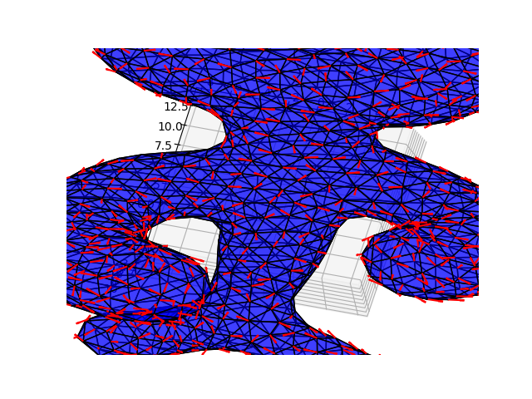

I also plotted the Gaussian curvature based on the holonomy around each triangle (Ω in the paper):

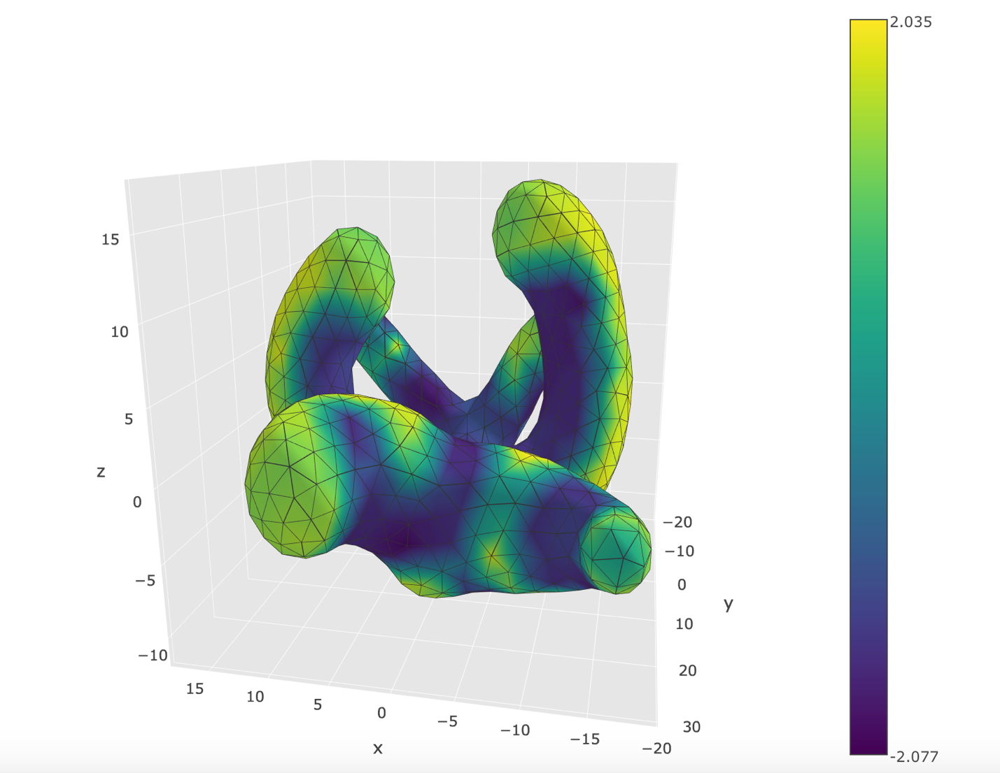

This seems to be correct, which means there’s probably an error in my parallel transport calculation or in constructing the direction field from *u.*

My next steps in the project are going to be

1. finishing and verifying my implementation of [2]
2. writing code to visualize my implementation of [1]
3. extending these implementations as described in my project proposal.

**Related Work**

[1] “Stripe Patterns on Surfaces”. Knöppel et. al. ACM Trans. on Graph (2015). <https://www.cs.cmu.edu/~kmcrane/Projects/StripePatterns/paper.pdf>

[2] “Globally Optimal Direction Fields”. Knöppel et. al. ACM Trans. on Graph (2013). <https://www.cs.cmu.edu/~kmcrane/Projects/GloballyOptimalDirectionFields/paper.pdf>

1. I don’t necessarily *need* to compute the direction field in this exact manner, but [1] references [2], so the two go together pretty well.